LAB 3 Report
Wenbo Geng
916207638

Non-Leaf RISC-V Procedure:
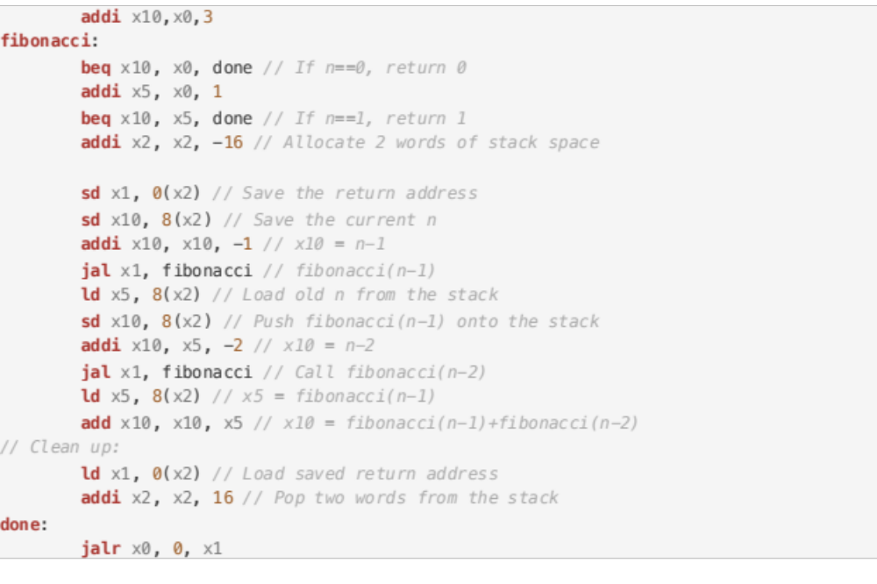
Code Block 1: Part 1 Code
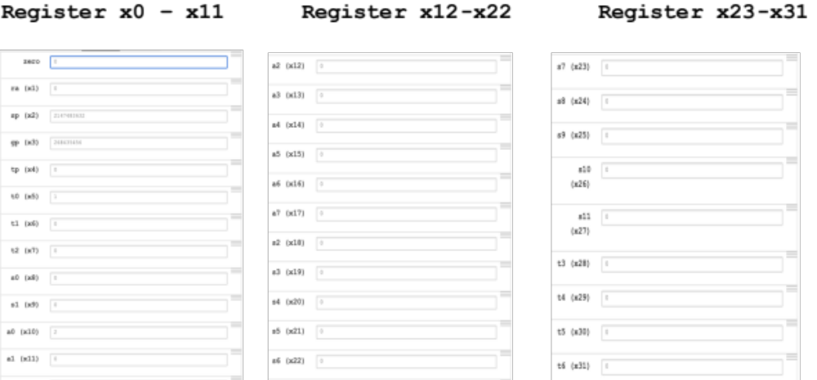

Part_1: Register Screen Capture
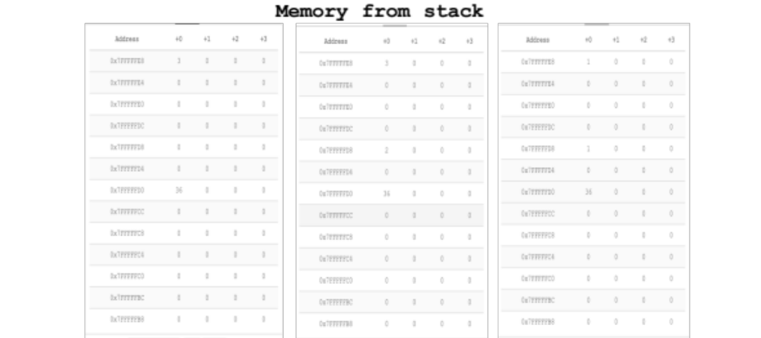

Part_1: Memory Screen Capture
Basically we need a stack to record the path of the integer n which it is stored. For example, to calculate fibonacci(3), we must calculate fibonacci (2) and fibonacci (1) first. In order to track back which statement the fibonacci(n-1) or fibonacci (n-2) we need to go back. We need to use a stack memory to track the path until the value is one or zero then we can pop the two word from the stack.
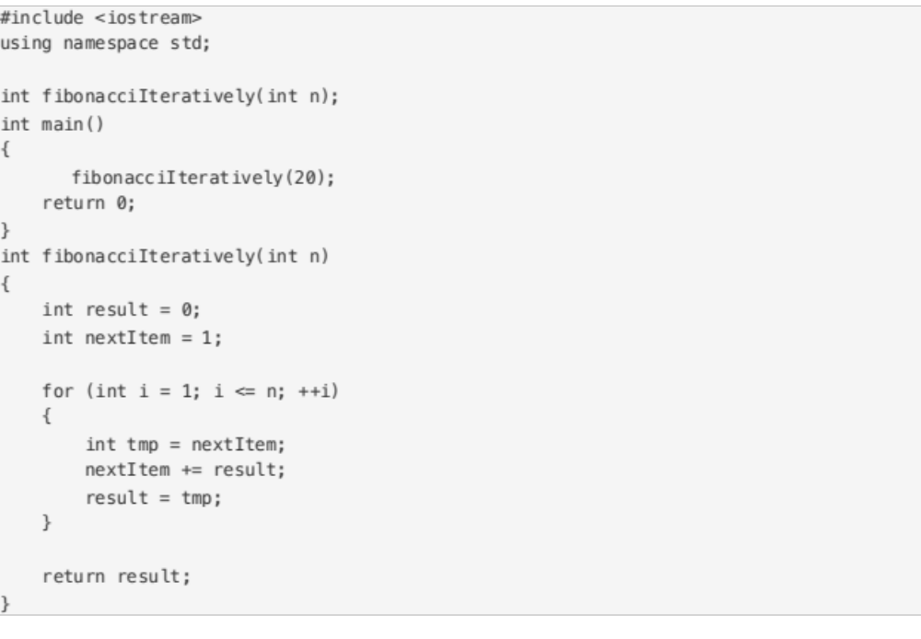
Code Block 2: Part 2 Code_C

Since 20 is a 8 bits number and the website can’t use ld as double word and lw is a 4 bits. So I use iteration to implement ficbonacci(20)
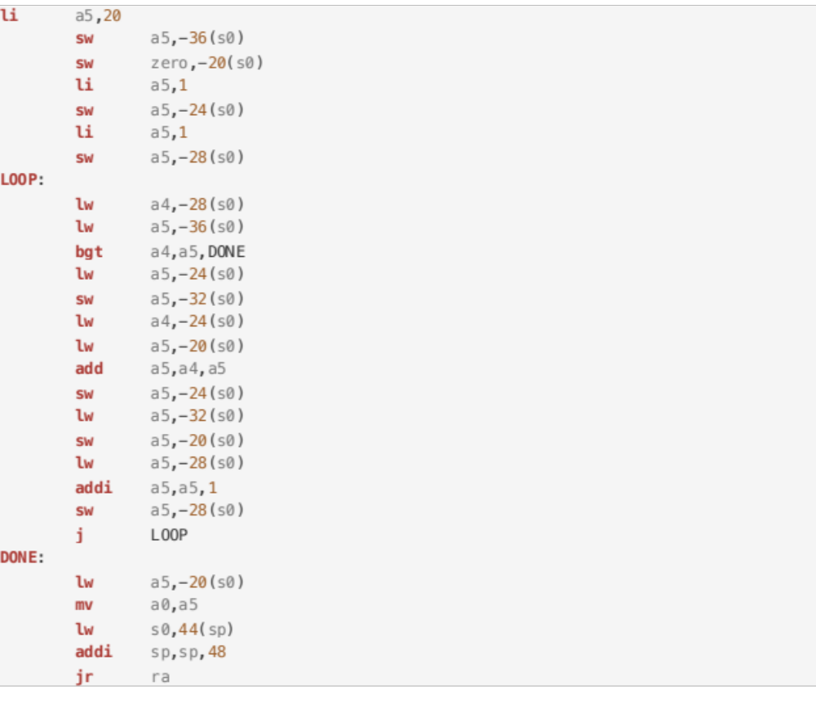 Code Block 2: Part 2 Code

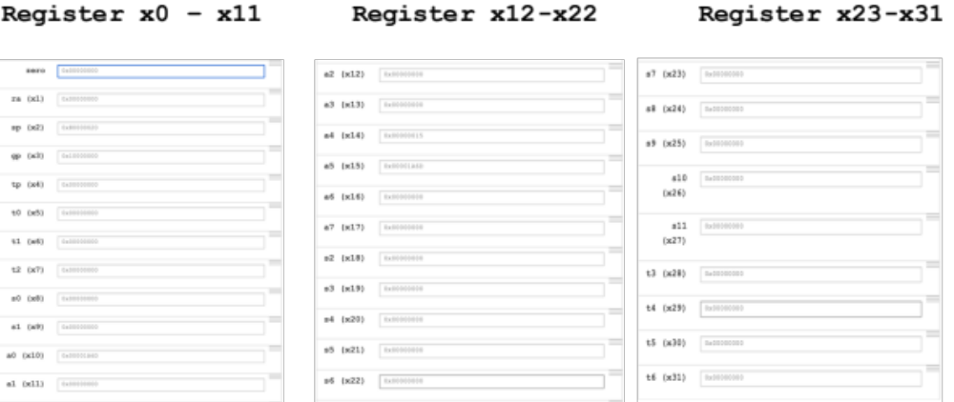
Part_2: Register Screen Capture
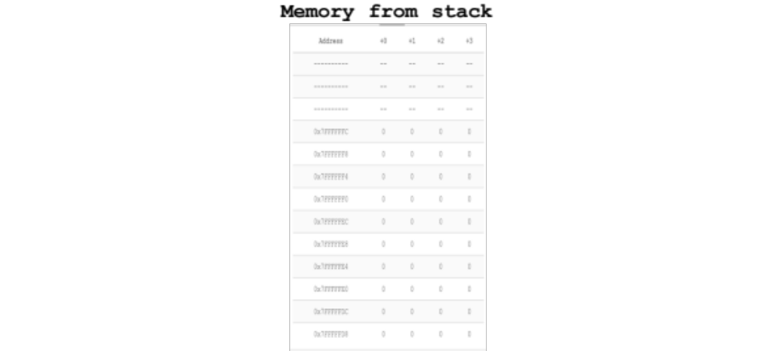

Part_1: Memory Screen Capture
For Fibonacci(20) I used a iteration so the for loop is not a function call, it doesn’t do anything with the parameter stack. Which I didn’t use stack memorys

